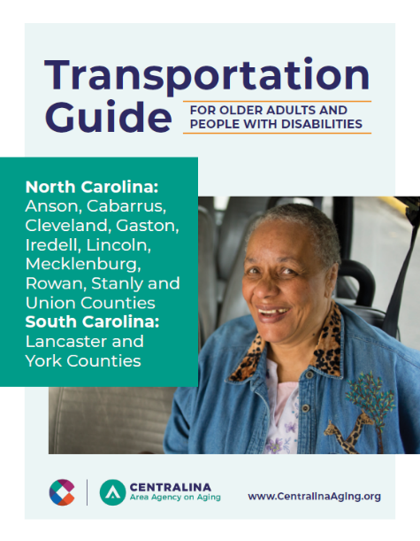
What is the Transportation Guide?
The Transportation Guide is a resource designed by Centralina Area Agency on Aging to aid both individuals and community service agencies. The Guide is available in both hard copy and electronic version. It includes definitions of the different types of transportation services, and lists contact information for the corresponding services agencies across the nine-county Centralina region as well as our neighboring counties to the south--Lancaster and York Counties in South Carolina.
In addition to helpful tips and considerations when using transportation services, the Guide also explains services such as Lyft and Uber and how to use them. A Transportation Needs checklist is also included to help individuals clarify their transportation needs.

What is the Transportation Toolkit?
Community service agencies are tasked with more responsibilities than ever before, including providing resource information to clients and educational programs for participants. In response, Centralina AAA has created a resource toolkit that that offers something for everyone including service agency staff, older individuals who drive, and those who need transportation services. Among the toolkit resources is a brief PowerPoint presentation that can easily be shown to participant groups. We’ve included a bit of transportation trivia and games as well!

How to Use the Resource Guide and Toolkit
For Individuals & Their Caregivers
Use the Transportation Guide to understand the various types of public transportation available, and how to access these services. Complete the Transportation Needs Checklist to review your transportation needs based on where you need to go, evaluate your existing transportation support network, and explore what possible alternatives might be available.

Service providers who work with older and disabled adults -
Senior Centers and Nutrition Sites can create a customized activity for participants using the Guide along with additional components from the toolkit to meet your programming needs. You can also achieve SCOPE requirements, such as providing information and assistance, community resources and referrals, and building new partnerships with transportation providers.
Other human services and healthcare agencies that provide any kind of information and referral services should use the Guide—and share it with others--as a helpful resource.

